Ideation Phase
Empathize & Discover
Date | 01 October 2026
Team ID | SWTID-2026-5003
Project Name | Implement Client Script & UI Policy (Incident)
Maximum Marks | 4 Marks

Empathy Map
Empathy map prepared from the project problem statement, focusing on the Incident record user and the challenges caused by incomplete, inconsistent, or incorrect data entry.
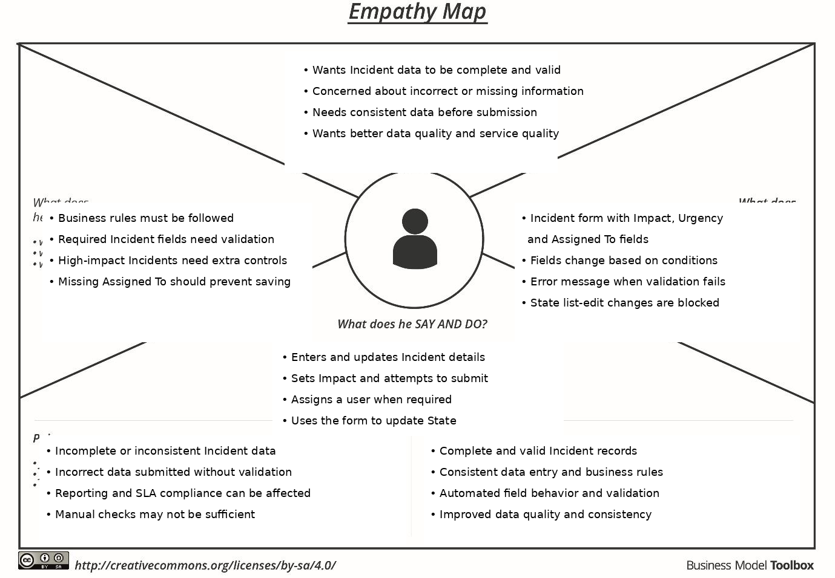
Source basis: Project Problem Statement and Objective

